# What percent of sales occurred at each store type?

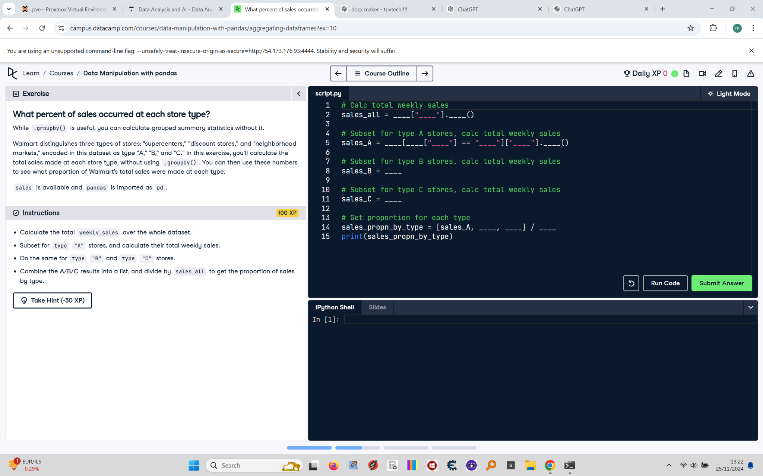

While .groupby() is useful, you can calculate grouped summary statistics without it.  
  
Walmart distinguishes three types of stores: 'supercenters,' 'discount stores,' and 'neighborhood markets,' encoded in this dataset as type 'A,' 'B,' and 'C.' In this exercise, you'll calculate the total sales made at each store type, without using .groupby(). You can then use these numbers to see what proportion of Walmart's total sales were made at each type.  
  
sales is available and pandas is imported as pd.

## Final Corrected Answer

# Calc total weekly sales  
sales_all = sales["weekly_sales"].sum()  
  
# Subset for type A stores, calc total weekly sales  
sales_A = sales[sales["type"] == "A"]["weekly_sales"].sum()  
  
# Subset for type B stores, calc total weekly sales  
sales_B = sales[sales["type"] == "B"]["weekly_sales"].sum()  
  
# Subset for type C stores, calc total weekly sales  
sales_C = sales[sales["type"] == "C"]["weekly_sales"].sum()  
  
# Get proportion for each type  
sales_propn_by_type = [sales_A, sales_B, sales_C] / sales_all  
print(sales_propn_by_type)